# ***Environmental monitoring***

***Phase 3***

|  |  |
| --- | --- |
| Date | 18 October 2023 |
| Team ID | NM2023TMID449 |
| Project Name | Environmental Monitoring |
| Team Name | proj_227236_Team_1 |

# In this part you will begin building your project.

# Start building the IoT-enabled Environmental Monitoring in Parks system.

# Deploy IoT devices (e.g., temperature and humidity sensors) in various locations within public parks to measure environmental conditions.

# Develop a Python script on the IoT devices to send real-time environmental data to the monitoring platform.

**Program:**

"""

'temp_humidity.py'

==================================

Example of sending analog sensor values to an Adafruit IO feed.

Author(s): Brent Rubell

Tutorial Link: Tutorial Link: https://learn.adafruit.com/adafruit-io-basics-temperature-and-humidity

Dependencies:

- Adafruit IO Python Client

(https://github.com/adafruit/io-client-python)

- Adafruit_Python_DHT

(https://github.com/adafruit/Adafruit_Python_DHT)

"""

# import standard python modules.

import time # import adafruit dht library.

import Adafruit_DHT # import Adafruit IO REST client.

from Adafruit_IO import Client, Feed

# Delay in-between sensor readings, in seconds.

DHT_READ_TIMEOUT = 5

# Pin connected to DHT22 data pin

DHT_DATA_PIN = 26

# Set to your Adafruit IO key.

# Remember, your key is a secret,

# so make sure not to publish it when you publish this code!

ADAFRUIT_IO_KEY = 'YOUR_AIO_KEY'

# Set to your Adafruit IO username.

# (go to https://accounts.adafruit.com to find your username). ADAFRUIT_IO_USERNAME = 'YOUR_AIO_USERNAME'

# Create an instance of the REST client.

aio = Client (ADAFRUIT_IO_USERNAME, ADAFRUIT_IO_KEY)

# Set up Adafruit IO Feeds.

temperature_feed = aio.feeds('temperature')

humidity_feed = aio.feeds('humidity')

# Set up DHT22 Sensor. dht22_sensor = Adafruit_DHT.DHT22

while True:

humidity, temperature = Adafruit_DHT.read_retry(dht22_sensor, DHT_DATA_PIN)

if humidity is not None and temperature is not None:

print('Temp={0:0.1f}*C Humidity={1:0.1f}%'.format(temperature, humidity))

# Send humidity and temperature feeds to Adafruit IO

temperature = '%.2f'%(temperature)

humidity = '%.2f'%(humidity)

aio.send(temperature_feed.key, str(temperature))

aio.send(humidity_feed.key, str(humidity))

else:

print('Failed to get DHT22 Reading, trying again in ',

DHT_READ_TIMEOUT, 'seconds')

# Timeout to avoid flooding Adafruit IO

time.sleep(DHT_READ_TIMEOUT)

**Output:**

Traceback (most recent call last):  
 File "./prog.py", line 22, in <module>  
ModuleNotFoundError: No module named 'Adafruit_DHT'

IoT-Based Temperature and Humidity Real-Time Monitoring

RELATED WORK

A system is developed in [1] to sends measurement data of temperature and humidity to a cloud platform using HTTP (Hypertext Transfer Protocol)based servicesusing energy autonomous wireless sensors. Air quality monitoring device [2] monitors overall toxic gases like NOx, CO2, benzene and smoke by comprising of a NodeMCU ESP32, a MQ135 gas sensor and a DHT-11 temperature and humidity sensor module. Also displays an alert message on server if the air quality parameters exceed the standard value.AquaponicsMonitoring and automatic correction system set-up in a temperature controlled greenhouse including pH level and temperature of the recirculating water [4]. A remote monitoring system of temperature and humidity based onOneNet cloud service equipped with STM32F103RCT6 of ARM CortexM3 kernel, SIM800C communication module and GSM/GPRS cellular communication technology having data detection and alarm function [5]. Another proposed system is developed to observe air pollution information at public facilities or homes which is capable to collect and analyze atmospheric environment measurement results in a server through an LTE communication network [6, 8].An IoT-based environmental monitoring system is developed for indoor workplaces to compare the energy consumptions for environmental control with the real environmental wellness [7].Smart environmental monitoring is to help in the protection of environment

Via parameters for monitoring such as quality of air and quality of water [9]

DESIGN METHODOLOGY

The system consists of a temperature and humidity sensor DHT11, ESP8266 Wi-Fi module, DC-DC Motor, Solar panel and Arduino UNO Board. Arduino UNO is a microcontroller board based on the ATmega328P (datasheet). It has 14 digital I/O pins, 6 analog inputs, a 16 MHz ceramic resonator(CSTCE16M0V53-R0), a USB connection, a power jack, an ICSP header and a reset button. Six digital pins can be used as PWM outputs It contains everything needed to support the microcontroller; simply connect it to a computer with a USB cable or power it with an AC-to-DC adapter or battery to get started. Fig. 1 shows the Arduino UNO Board.

Fig. 1: Arduino UNO Board

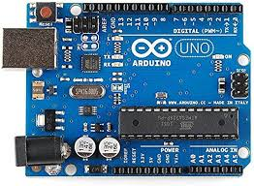

The ESP8266 is a Wi-Fi module that allows microcontrollers access to a Wi-Fi network. This module is a self-contained SOC (System on a Chip) that does not necessarily need a microcontroller to manipulate inputs and outputs. Fig. 2 shows the ESP8266 Wi-Fi Module.

Fig. 2: ESP8266 Wi-Fi Module

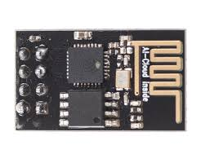

The DHT-11 sensor is made of two parts, a capacitive humidity sensor and a thermistor. It is a device of ultra-low cost with 1 Hz sampling rate (once every second). It provides 20-80% humidity readings with 5% accuracy and 0-50°C temperature readings with ±2°C accuracy.

Fig. 3 shows the DHT-11 sensor.

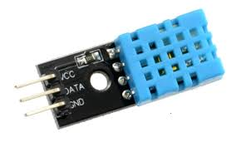

Applications

Humidity sensing enables a host of value-added Applications in various industries, including cold storage management, comfort optimization, asset condition tracking, and remote monitoring.

Humidity Sensors in Cold Storage Management

In cold storage management, humidity sensing ensures proper storage conditions for temperature-sensitive products such as food, beverage, and pharmaceuticals.

Humidity sensors contribute to regulatory compliance and to automating the auditing of the status of the equipment. In conjunction with temperature sensors, they also contribute to increasing product safety, while reducing waste.

Overall, the combination of temperature sensors and humidity sensors in cold storage management enables the development of powerful regulatory compliance tools, automation of audits, increased product safety, and improved environmental performance.

Humidity Sensors in Smart Buildings & Facilities Management

In smart buildings, humidity sensors are deployed to improve the comfort offered to tenants and occupants. For example, they provide insights on certain rooms’ moisture conditions, which can subsequently drive the fine-tuning of the rooms’ conditions through the Building Management System (BMS).

By adding humidity sensors to HVAC systems and office environments, Facilities Managers can efficiently monitor, measure, and adjust humidity to provide a comfortable and productive working environment. In many cases, humidity sensors enhance temperature monitoring functionalities towards increased comfort and fine-tuning of energy consumption.

Beyond comfort, humidity sensing is essential to ensuring proper conditions for valuable assets. For example, galleries, museums, and art collectors can maintain stable environmental conditions for their collections. For this purpose, they should keep track of humidity changes, as moisture can be catastrophic for paintings, drawings, prints, mosaics, and sculptures. Humidity monitoring helps galleries and museums protect their assets and lower their insurance costs.

Humidity Sensors in Remote Monitoring and Intelligent Asset Management

Humidity sensors are also integral elements of remote monitoring and intelligent asset management Applications. They can be deployed on assets (e.g., pumps, compressors, fans, data centers) to facilitate a transition from preventive to predictive maintenance.

Specifically, humidity sensor data streams can enhance the accuracy of predictive analytics for condition-based monitoring. They also enable the real-time monitoring of humidity to identify problems (e.g., potential leakages) before they occur. In these ways, humidity sensors extend the lifetime of critical assets and maximize their overall efficiency.

In many cases, humidity sensing is used in conjunction with other sensing types (e.g., temperature, proximity, touch, water) to offer additional value-added services in smart buildings and facilities management contexts. Complete sensing solutions help set Facilities Managers apart from their competitors.

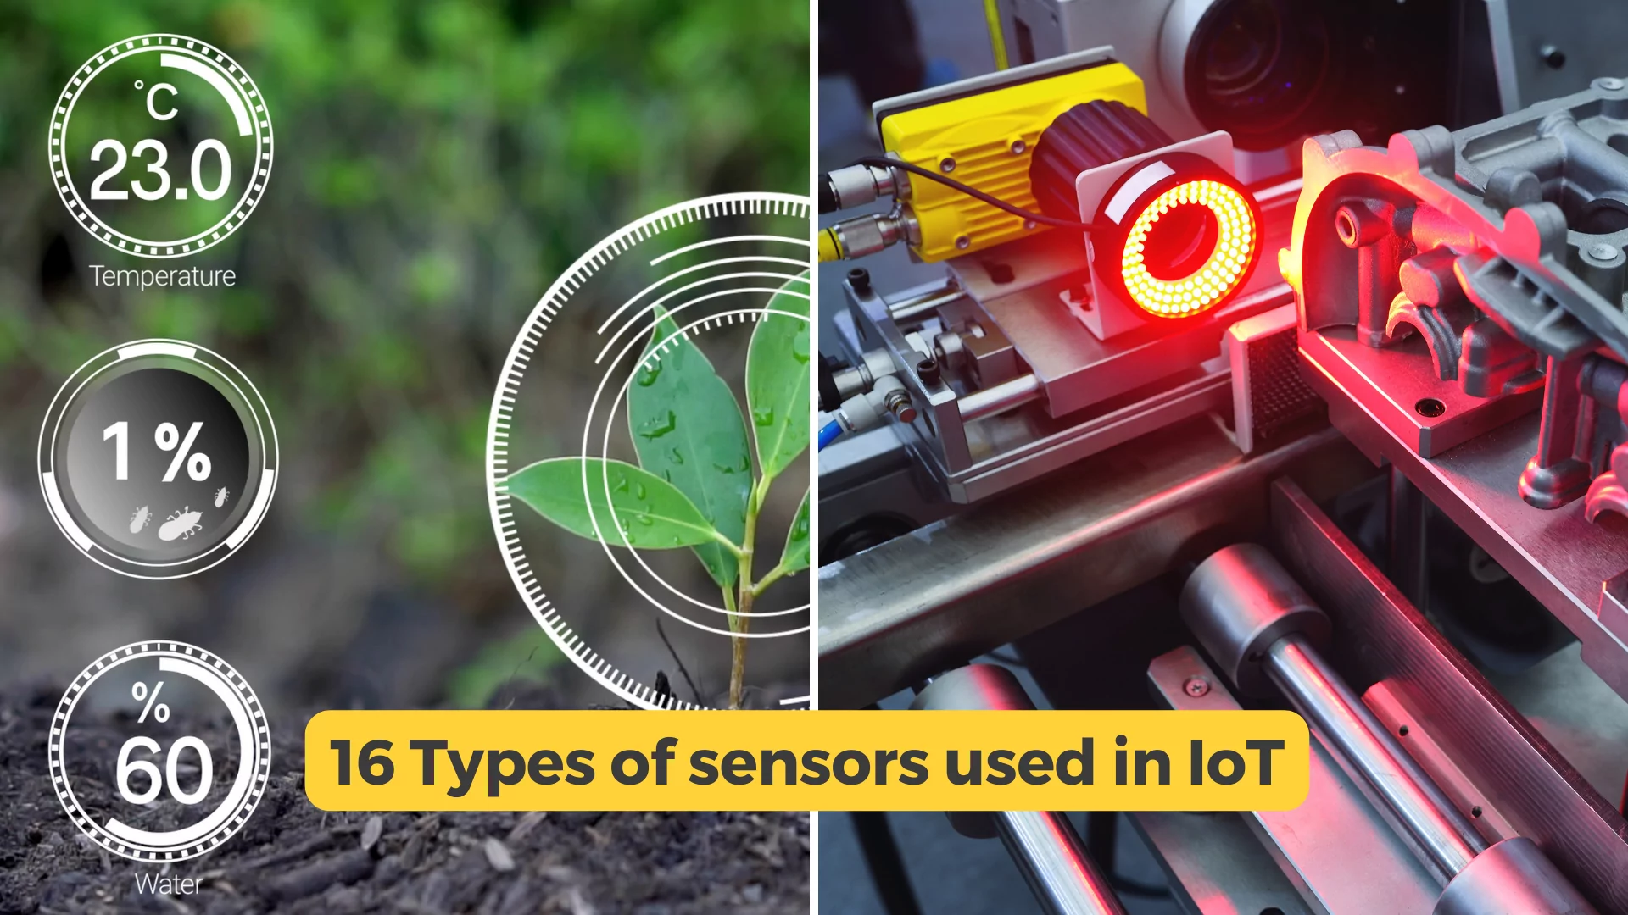

The Internet of Things (IoT) is a network of physical devices, interfaces, and other items embedded with sensors, actuators, electronics, and connectivity. These devices collect data from their environment through IoT sensors and communicate it to systems. Data from [**IoT sensors**](https://freeeway.com/use-cases/sensors/) can be used better to understand a system or process for further actions. It can also prevent tragedies, decrease usage costs, and simplify your everyday life.

IoT sensors are one of the key components in IoT devices that collect data from surroundings and transmit them over networks. This article covers a list of sensors used in IoT solutions, their role, and real-life examples.

## **Introduction to IoT sensors**

IoT Sensors are electronic chipsets or modules that sense the ambient or system conditions and transmit that data to the Internet through a gateway. These different sensors can function through physical contact, radiation, or magnetic fields.

There are two main types of sensors used in IoT applications:

* **Passive sensors:** detect changes in their environment without any dedicated power supply (e.g., temperature)
* **Active sensors:** require some form of power source to function (e.g., battery)

In a nutshell, IoT sensors measure the physical environment to collect data about things like temperature or air quality; they can then transmit the information via a network to gateways and the cloud. Once in the database, it can be analyzed further for the next course of action.

IoT sensors are often combined with other technologies, such as AI and cloud computing. For example, a sensor might measure temperature and humidity in a room and transmit that data to a cloud-based database, where it is analyzed to perform necessary operations.

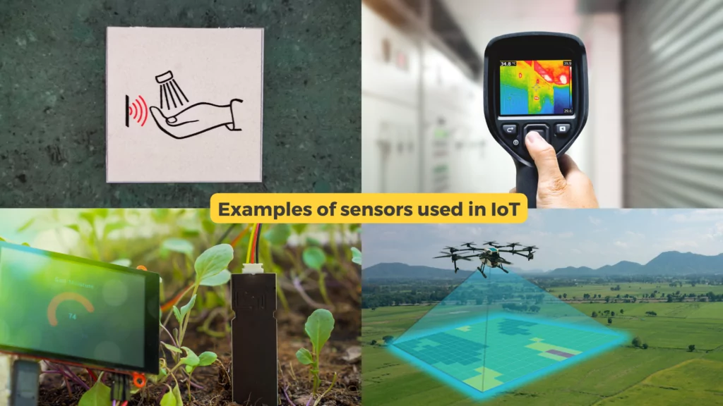

## **How are sensors being used in IoT? 16 examples of IoT Sensors**

A wide variety of IoT sensors are available in the market for different use cases and applications. Here is the breakdown of popular types of IoT sensors and how they are used in IoT:

**Temperature Sensors:** Temperature sensors or thermal sensors can detect the temperature of an object, surface, or environment. A temperature sensor measures and sends the temperature of something or someone to a cloud or other devices via a network. For example, a device like a thermostat is temperature-controlled using temperature sensors.

**Humidity Sensing:** Humidity sensor detects changes in moisture levels in different mediums like air, liquids, or solids. Humidity sensors detect the layer’s response to electronic signals through an electronic circuit that converts electrical signals into digital ones; Such humidity detection can also be used in thermostats and other wetness detection solutions.

**Fire Detection Sensors:** As the name suggests, fire detectors are used to detect smoke and heat. Such detection can be helpful in industrial operations and smart buildings. For example, fire detection can detect smoke and heat from combustion processes within combustion chambers like furnaces.

**Light Sensors:** Light sensors are photodetectors that are designed to detect visible light. These sensors are used for smart street light automation to measure luminance from various light sources, such as sunlight. Light sensors can be useful to turn on lights when sunlight is low or unavailable automatically.

**Proximity Sensors:** Proximity sensors can help identify if there are nearby objects, animals, or humans passing by. Such sensors detect the presence and take further necessary actions such as turning on lights, recording camera footage for safety, or even helping with car parking. Infrared sensors, ultrasonic sensors, optical sensors, and LiDAR can help with such proximity detection.

**Gas Detection Sensors:** Gas leak detectors can be used to identify a particular gas in the surroundings. It can help detect potentially dangerous gasses to avoid any harmful accident or effects on a particular user. An example of such detection can be detecting hydrogen sulfide, a gas found in natural gas pipelines that causes explosions if not detected in any leaks.

### 

### **Get a free IoT Connectivity White Paper**

#### Curious to learn more about M2M & IoT SIM cards? “The Ultimate Guide to IoT SIMs”

These are just a few examples of how sensors are being used in IoT to improve our daily lives. As technology continues to evolve, we can expect even more innovative sensor data applications in the future. Other than these, there are many IoT sensors available in the market to detect pressure sensors, acceleration detectors, air quality detectors, and many such IoT devices.

## **The future of IoT sensors**

The future use of IoT sensors is incredibly promising, and we can expect to see these devices integrated into even more aspects of our daily lives. For instance, in healthcare, wearable sensors can provide real-time monitoring of patients, allowing doctors to track vital signs and detect early signs of illness. IoT sensors can also be used to optimize energy usage and reduce waste in smart homes and buildings. They can even be applied to improve worker safety and efficiency in industrial settings. In agriculture, IoT sensors can monitor soil moisture levels, track crop growth, and detect early signs of pests or diseases.

As we continue to develop more advanced IoT technology, we can expect to see even more innovative uses of sensors in various applications, from smart cities to transportation. With the vast amounts of data that can be collected from these sensors, the possibilities for improving efficiency, sustainability, and quality of life are endless. IoT sensors are used in smart cities, homes, and factories. If there is an IoT solution, the chances are there is some IoT sensor involved in the process. They’re also used across industries like agriculture, transportation, healthcare, and manufacturing.

As we move towards a more connected and data-driven world, the future of IoT sensors is bright, and we can look forward to exciting developments in this field.

## **IoT Connectivity for IoT Sensors**

IoT sensors are the fundamental element of any IoT solution. Their power consumption, accuracy, and precision can affect the overall functioning of an IoT-powered smart device. If you are looking for global IoT SIM Cards or an

[**IoT Connectivity Management Platform**](https://freeeway.com/products/cmp-connectivity-management-platform/) to power and manage your IoT sensors, fill out the contact form below to get a free IoT connectivity demo and a set of free M2M SIM cards from Freeeway.

Traceback (most recent call last):